* **Activity 11:**

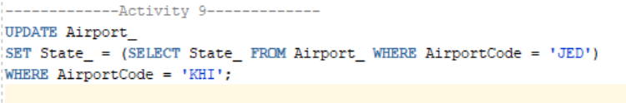

OUTPUT: